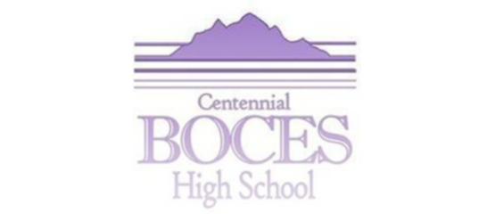

WHO IS THIS SCHOOL APPROPRIATE FOR?
- Students who are at least 17 years of age or older
- Students who are behind in credits and want to graduate
- Students with significant attendance issues at their home school
- Students who need to prioritize a work schedule along with school
- Students who may need to help care for loved ones (pregnant mothers and fathers, etc.)
- Students who aren’t succeeding in the traditional school environment
- Students who want to get done so they can move on to college, trade school, employment, etc.
- “Non-traditional” students (Over the age of 21) who want to come back to receive a High School Diploma verses a GED
WHAT IS THE SCHEDULE LIKE?
- Traditional School Schedule (Mid-August to the end of May) Closed during summer months.
- Monday through Thursday, 7:30 A.M.-3:30 P.M. and select Fridays, 8 A.M.-12:00 P.M.
- Staff and students work directly together to form a schedule per student
- Schedules are based on a 20 hour per week minimum adherence.
- Students are also expected to check in with their advisors daily either through text or email
GENERAL INFORMATION ABOUT THE PROGRAM
- We have two schools with permanent facility at both our Greeley and our Longmont locations. (IBMC Campus)
- We are not an “online” program (i.e.: students must attend regularly and be making progress.
- We are not “credit based” (i.e: previous credits do not transfer over, nor do we give students a credit for completion of each subject)
- Nothing transfers in or out of our program
- All competencies are based both by computer work and projects (80% or higher in all subjects is required)
- All assignments are uploaded on the Google Classroom and can be accessed at home
- All tests and labs must be completed at school
- Students do not receive grades or a GPA, we do provide a monthly Progress Report
- The program is aligned to the state’s common core standards, approved by the CDE.
- There is no bell schedule, and no seat time or busy work required
- Students must sign up for a 3 hour slot each week that they must adhere to
- Teachers facilitate student learning and help students with whatever they choose to work on
- We have a traditional Graduation Ceremony with caps and gowns and pictures taken.
- If a student is unable to finish the same year they come to the program they may come back the following year to complete their graduation and pick up where they left off.

Questions? Call Nicole Jackson 970-352-7404 ext. 1184 for both the Greeley and Longmont locations.

