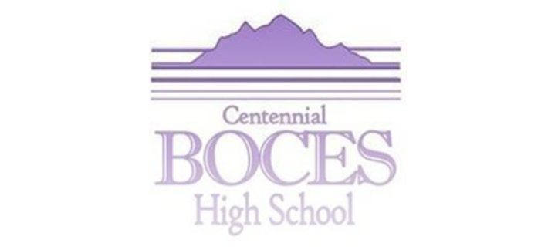
Longmont Office
2315 Main Street
Longmont, CO. 80501
303-645-3800 (Office)

Greeley Office
2020 Clubhouse Drive
Greeley, CO. 80634
970-352-7407 (Office)
970-352-7350 (Fax)

Member Districts
Johnstown RE5J
Platte Valley RE-7
St. Vrain Valley RE-1J
Weld RE-1
Ault-Highland RE-9
Briggsdale RE-10
Brush RE-2J
Eaton RE-2

www.cboces.org

Consent to be Photographed

I, the parent or legal guardian of the following child
give my consent for Centennial BOCES High School to photograph myself and my child. I understand such photographs may be used for educational purposes only. I also understand that such photographs, as well as our identities, may be published, and I waive any rights under applicable state or federal law to object to such publication. I further understand that I may revoke this consent at any time by providing written or verbal notice to Centennial BOCES.

Parent’s Signature Date

