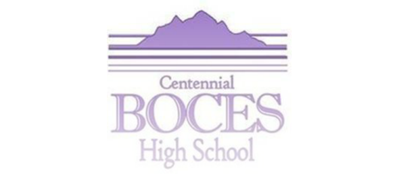

Digital Likeness Release Form

I hereby give Centennial BOCES permission to record my image and/or voice and grant Centennial BOCES the right to use these sound, still or moving images, hereafter called digital likeness, in any medium for educational, promotional, advertising, or other purposes that support our mission at Centennial BOCES.
I also agree to release, defend, and hold harmless Centennial BOCES, its board members, officers, and employees, including any firm publishing and/or distributing a finished product at the direction and on behalf of Centennial BOCES, whether on paper or via electronic media, from and against any claims, damages or liability arising from or related to the use of the digital likeness in accordance with the terms hereof, including but not limited to any distortion, blurring, alteration, optical illusion or use in composite form, either intentionally or otherwise, that may occur or be produced in taking, processing, reduction or production of the finished product, its publication or distribution.
I am 18 years of age or older and I am competent to contract in my own name. I have read this release before signing below, and I fully understand the contents, meaning and impact of this release. I understand that I am free to address any specific questions regarding this release by submitting those questions in writing prior to signing, and I agree that my failure to do so will be interpreted as a free and knowledgeable acceptance of the terms of this release.

Printed Name

Signature Date

