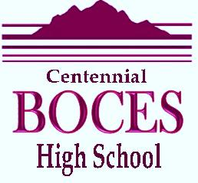

Centennial BOCES

2020 Clubhouse Drive

Greeley, CO 80634

Centennial BOCES High School

IBMC

[2315 Main St.](https://www.bing.com/local?lid=YN873x1930406193691766435&id=YN873x1930406193691766435&q=IBMC+College+Greeley&name=IBMC+College+Greeley&cp=40.3885154724121%7e-104.73681640625&ppois=40.3885154724121_-104.73681640625_IBMC+College+Greeley&FORM=SNAPST)

[Longmont, CO 80634](https://www.bing.com/local?lid=YN873x1930406193691766435&id=YN873x1930406193691766435&q=IBMC+College+Greeley&name=IBMC+College+Greeley&cp=40.3885154724121%7e-104.73681640625&ppois=40.3885154724121_-104.73681640625_IBMC+College+Greeley&FORM=SNAPST)

Language Survey

|  |
| --- |
| **This form must be completed by all students.** |

STUDENT NAME: ___________________________________________________________

DATE OF BIRTH: ________/______/_______

STUDENT:

Please answer the questions below accurately and completely. This information

is necessary to provide the most appropriate placement and instruction for you and will not be used for any other purposes. Thank you for your cooperation.

1. What was the first language that you spoke? _______________________
2. Is there a language other than English spoken in the home?  **⬜ No ⬜ Yes**

Which language(s) ___________________________________

1. Do you speak a language other than English? **⬜ No ⬜ Yes**

Which language(s) ___________________________________

1. In what language do you prefer to receive communication from the school?_____________________________________________

STUDENT SIGNATURE: _________________________________

DATE::_____________